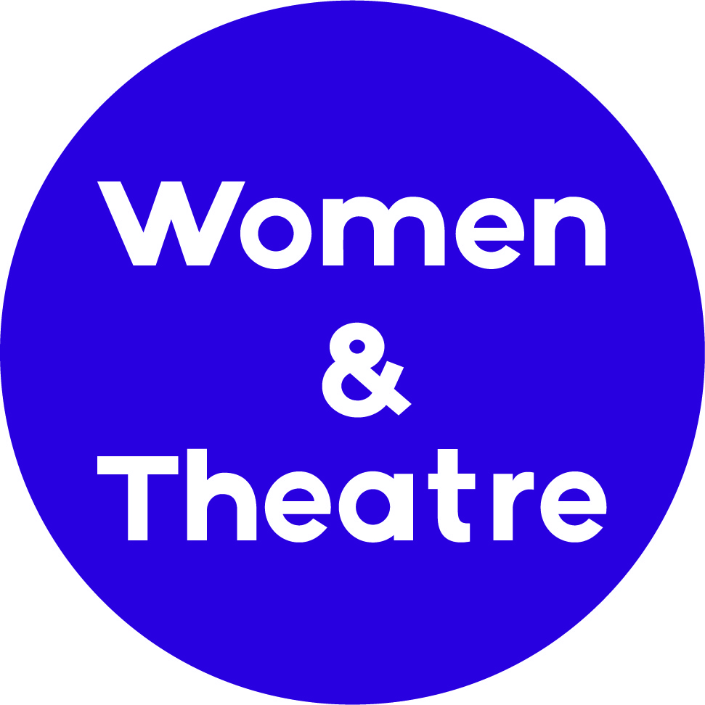

Factory Youth Theatre

February Half Term 2019

Dear Parent/Guardian

Factory Youth Theatre is an exciting and engaging week long theatre project for young people aged 12 to 16, taking place at The Factory Young People’s Centre, during February half term (18th to 22nd February).

This is an exciting opportunity to meet other young people, gain skills and produce a public performance for friends and family on the final day. The young people will learn about how to create stories, develop performance material and work as part of team in a fun and accessible way.

Project sessions will run 10am - 3pm Monday to Thursday and 10am – 6pm on the Friday (with a performance starting at 5pm) at The Factory Young People Centre, Longbridge, B31 2TW
There is also an opportunity for young people to complete a Bronze Arts Award. Young people wanting to gain this qualification will need to stay an extra hour after each session (finishing at 4pm), and attend a follow up session in February or March 2019.
Please complete and return this form to myself via email to jogleave@womenandtheatre.co.uk
If you have any questions about the youth theatre or the application form please don’t hesitate to contact me.

I look forward to meeting you during the project.

Best wishes,
Jo Gleave
Lead Artist Practitioner, Women & Theatre
0121 449 7117

APPLICATION FORM

To be completed and returned to Women & Theatre by INSERT DATE HERE
Please make sure that all sections are completed.

YOUNG PERSON'S DETAILS
Surname
Forenames

Ethnicity

Date of Birth |  |  | Gender
Current Residential Address

Telephone No.
Email address of parent/carer

School Placement (name and address) – will be used for licensing purposes

EMERGENCY CONTACT
Name
Relationship to YP
Telephone No.
Mobile Tel No.

Please let us know if any of the above information changes during the duration of the project.

How did you find out about Factory Youth Theatre?

.......................................................................................................................................................

Please complete the following page with reference to the potential risks listed below.

Issues relating to: | Risks may be from others to the young person or from the young person to others
Cultural Risks | Language needs, food requirements
Personality risks | Non-contact orders, people they don’t like etc?
Medical Risks | e.g. relating to food or drink including allergies, underlying medical conditions such as ASD, ADHD, Diabetes, visual, hearing or mobility impairment, asthma etc
Emotional Risks | Lack of sense of danger, Mental health issues, bullying
Physical Risks | e.g. Self Harming, threats of self-harming, violence towards peers, carers, teachers, or others
Behavioural Risks | e.g. Aggression, shouting out, stealing, lying, inappropriate sexual behaviour, refusal to stay in seat, issues as a result of drugs, alcohol or solvent abuse?
Safeguarding Risks | e.g. Family members, friends or associates who present a risk of harm, Truancy from school, transport to and from school, child protection issues, outstanding investigations
 | Any other factors/trigger points which should be taken into consideration?

IDENTIFIED RISKS – YOUNG PERSON
Identified Risks (Please enter source of information and whether based on previous incidents or concerns) | Nature of Risk | Who is at Risk | Major, High, Moderate or Minimal risk (Probability) | Recommended control measures/action plan to reduce probability of risk
Name and status of person completing risk section of this form
Signature and Date

Individual Consent Form – Media

Description of Project: Factory Youth Theatre is a weeklong theatre workshop working with young people in Longbridge.

Dates: 18th to 22nd February 2019

Description of how & where images and films will be used:
During the week, W&T will be taking photographic and film footage of the Young People. These images and films will be used for promotional purposes and evaluation and as such, some images and films may be used on social media (Twitter / Instagram / Facebook) and websites for Women & Theatre and our host venue Factory Young People Centre. Images and films may also be used in printed materials such as performance programmes, marketing information, press articles, leaflets and evaluation reports.

No full names will be given at any time.

Anonymity
Should your YP need anonymity, we are able to find ways of photographing and filming them without showing their face.

Young Person’s Name: _________________________________________________

Please read carefully, and tick ONE box in the following section:

I give permission for the above named young person to be photographed and filmed in

relation to the project described above including marketing purposes.

I give permission for the above named YP to be photographed and filmed in relation to the

project, including marketing purposes, AS LONG AS THEIR FACE IS NOT SHOWN.

I DO NOT give permission for the above named young person to be photographed and filmed

Name:
Role:
Signed:
Secondary Signature (if required):
Date:
Please return by email to jogleave@womenandtheatre.co.uk along with the application form.

